UNIT 1: Mini assessment 2
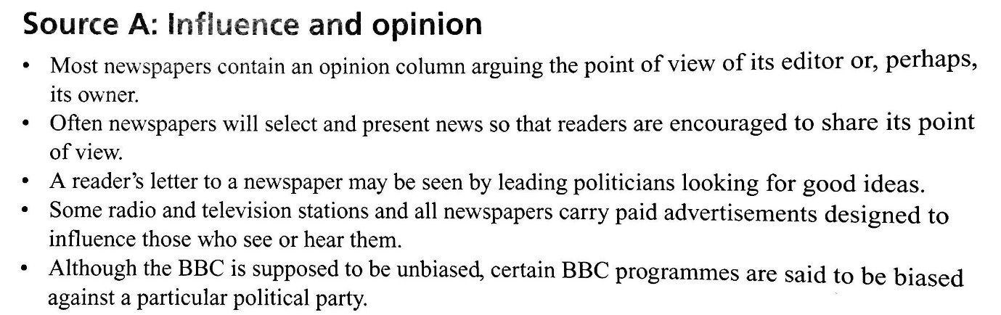
- Define the term ‘mitigating’. (1 mark)

- What is a probation officer? (2 marks)

- What is a small claims court? (2 marks)

- Using Source A and your own knowledge. Explain two ways in which public opinion may be influenced by what is printed in the newspapers. (4 marks)

- Using Source A and your own knowledge. ‘Television and radio are much less biased than newspapers.’ Explain two reasons why this claim might be true. (4 marks)

- ‘All terrorists are evil.’
Do you agree with this point of view?
Give reasons for your opinion, showing you have considered another point of view. You should support your argument with examples wherever possible. (12 marks)

Answer technique
To answer the above question, you could consider the following points and other information of your own.
- What is a terrorist (look up a definition)
- Why might people commit acts of terror?
- Do people have a human right to behave in any way they choose?
- Why does it matter if people from different cultures have different perspectives on what is right and wrong?
- What are the effects on terrorism, is it ever successful?
You may need to undertake some research prior to undertaking this question.

