UNIT 1: Mini assessment 1
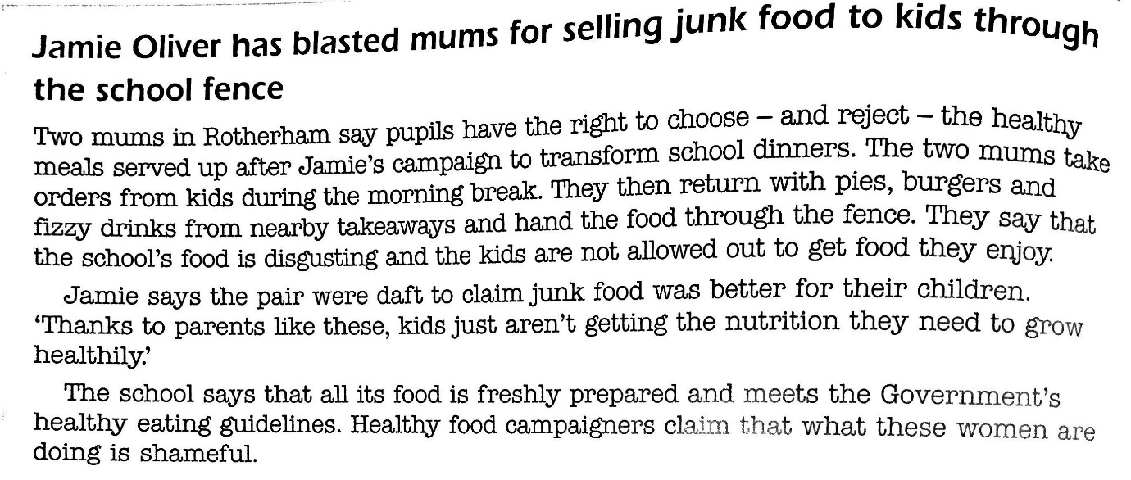

- Explain one right that the two mums are claiming for the children at the school. (2 marks)

- Explain one right that Jamie is calming for the children at the school. (2 marks)

- Identify two rights that children living in a third world country may not have. (2 marks)

- What is the role of the United Nations Universal Declaration of Human rights? (2 marks)

- ‘In multicultural Britain, people should not try to live separate lives.’
Do you agree with this point of view?
Give reasons for your opinion, showing you have considered another point of view. You should support your argument with examples wherever possible.
To answer the above question, you could consider the following points and other information of your own.
- Why might people from different cultures want to live separate lives?
- Do people have a human right to live their lives in whatever way they choose?
- Why does it matter if people from different cultures choose to live separate lives?
- What are the advantages of people from different cultures going to the same schools and living in the same neighbourhoods?

