Citizenship- Research Project

Task 1- You must find an article on litter on the BBC or another website.
Print out an article on littering and find 3 key points from the article. Copy and paste the link
Kids get recycling message
http://menmedia.co.uk/manchestereveningnews/news/s/1095903_kids_get_recycling_message

For example

Task 2- You must produce a leaflet or poster on the issue of littering of Beauchamp’s.

- Definition of littering
- Why is it a problem for staff and students at Beauchamp’s?
- Key causes of litter within the school?
- Who do you feel has the biggest influence on the school?

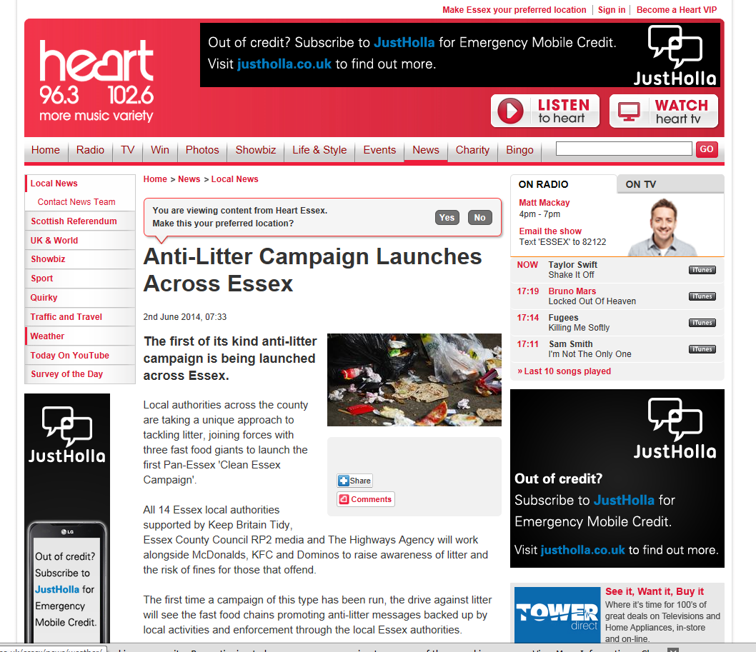

Task 3- You must produce a PowerPoint presentation for year 7 students
You must produce a PowerPoint presentation aimed towards year 7’s as they arrive at the school in 2015. It should inform them of the problems caused by littering, the schools expectations and their responsibility as a student at Beauchamp’s. (Minimum of 6 slides)

Attach your presentation to this sheet.

Task 4- You must produce a questionnaire aimed at students within Beauchamp’s.

Why do people litter?
What would stop them from littering?
Do they feel littering is a problem?

An example below.

Task 5- Visit the below websites and research the issues that the council of Manchester and Essex have identified.

http://www.manchester.gov.uk/environment/

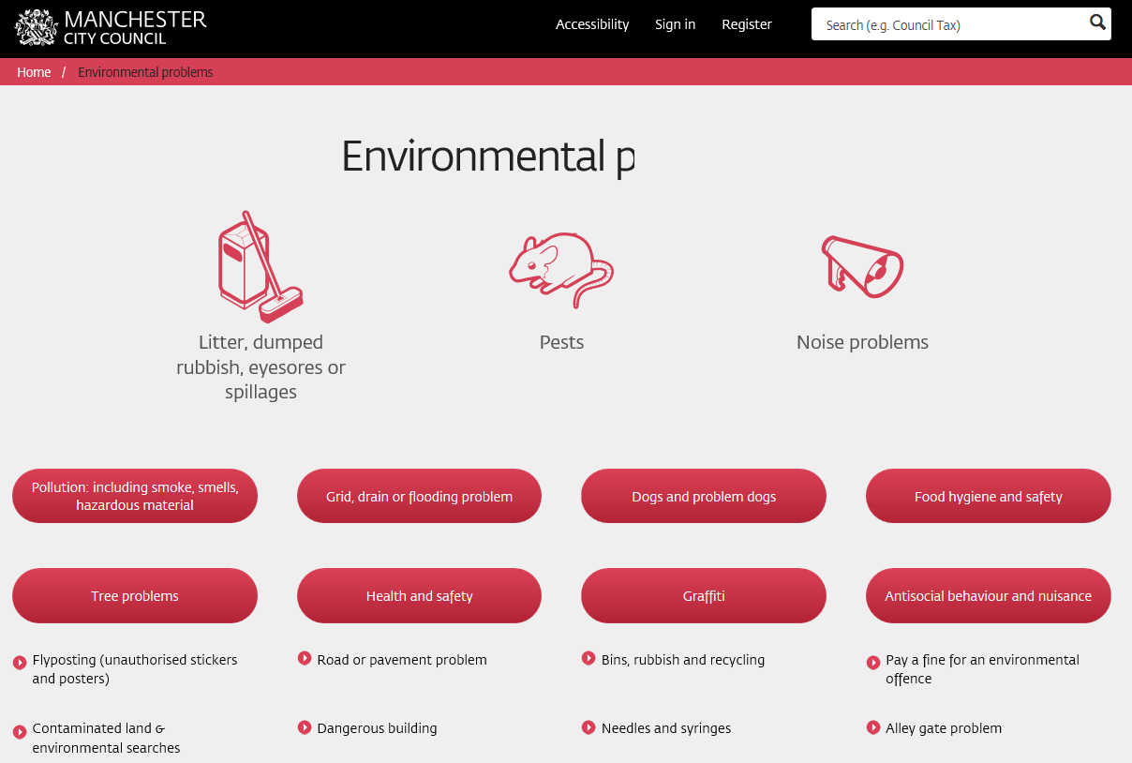

http://www.essex.gov.uk/Environment%20Planning/Environmental-Issues/Pages/Default.aspx/

Useful websites to consider.

Recycle now: www.recyclenow.com
Choose to reuse: www.Gigolt.org
Recycling guide: www.recycling-guide.org.uk

