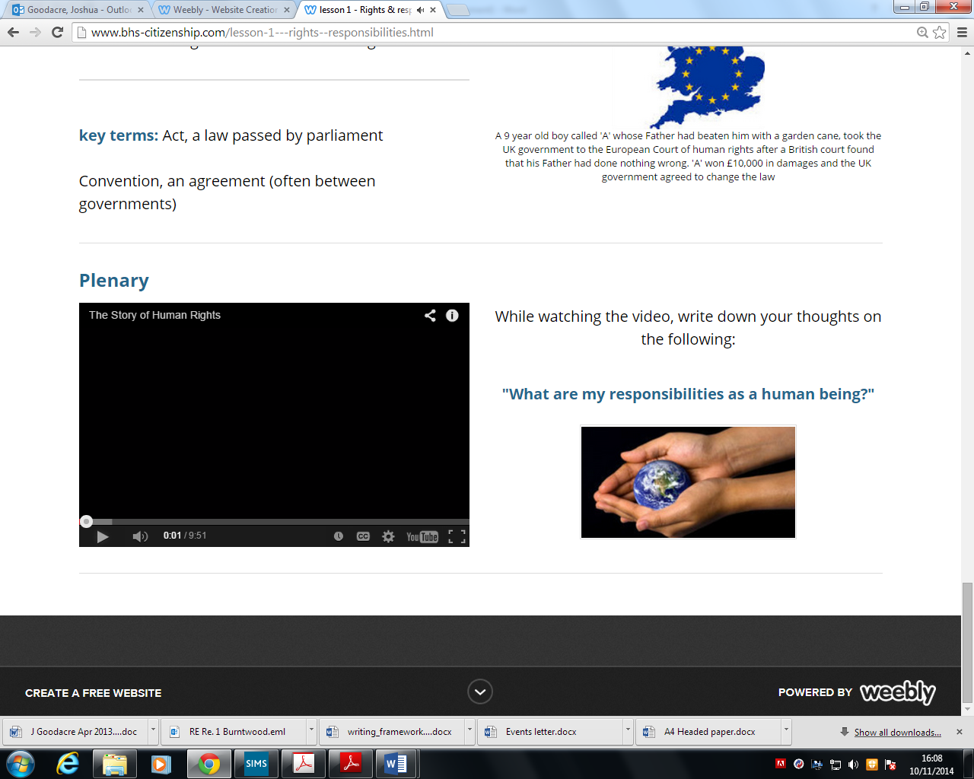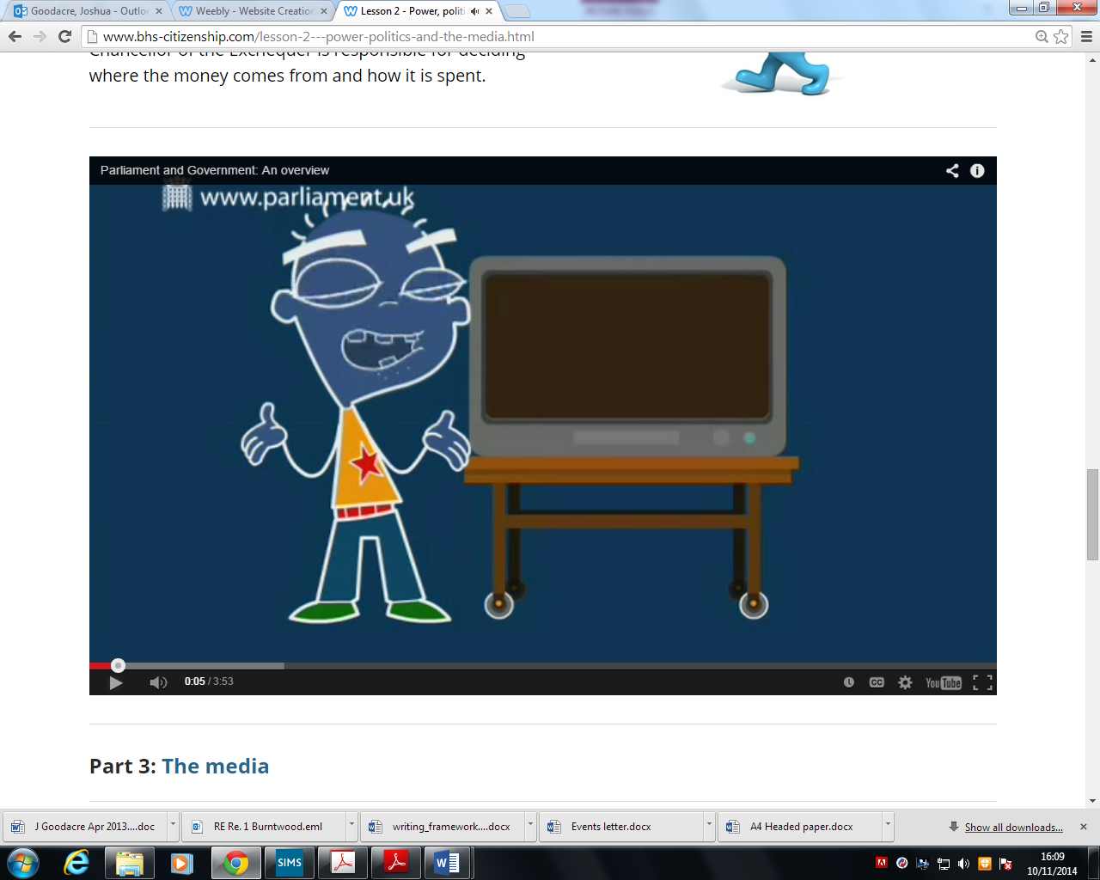

Parliament and Government – explains the role of each

The story of human rights – about the rights each person is entitled to

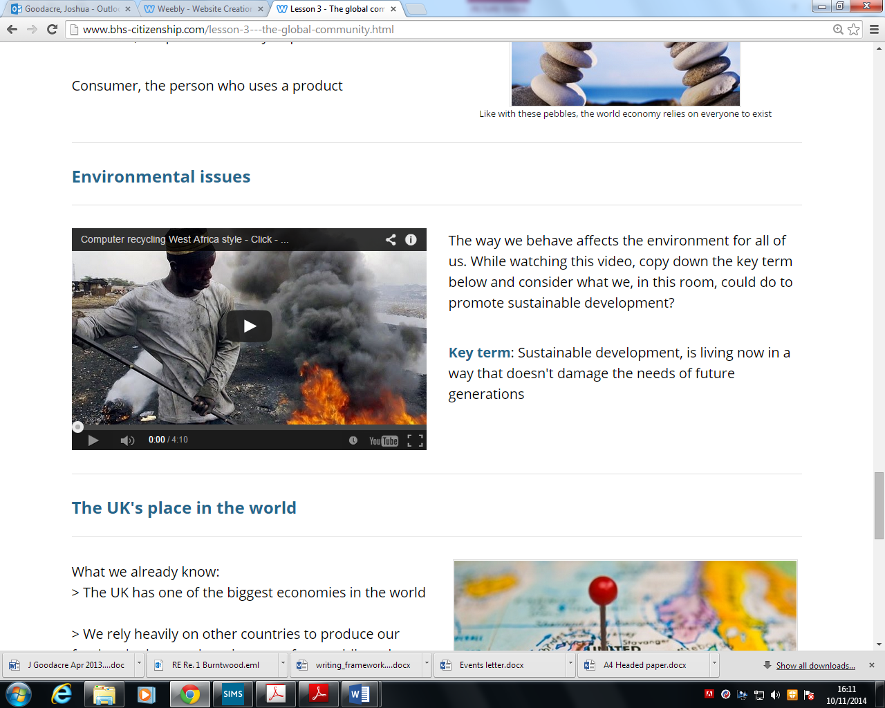

Computer recycling in West Africa – how broken computers from western countries are shipped to Africa and recycled in dangerous conditions by local people

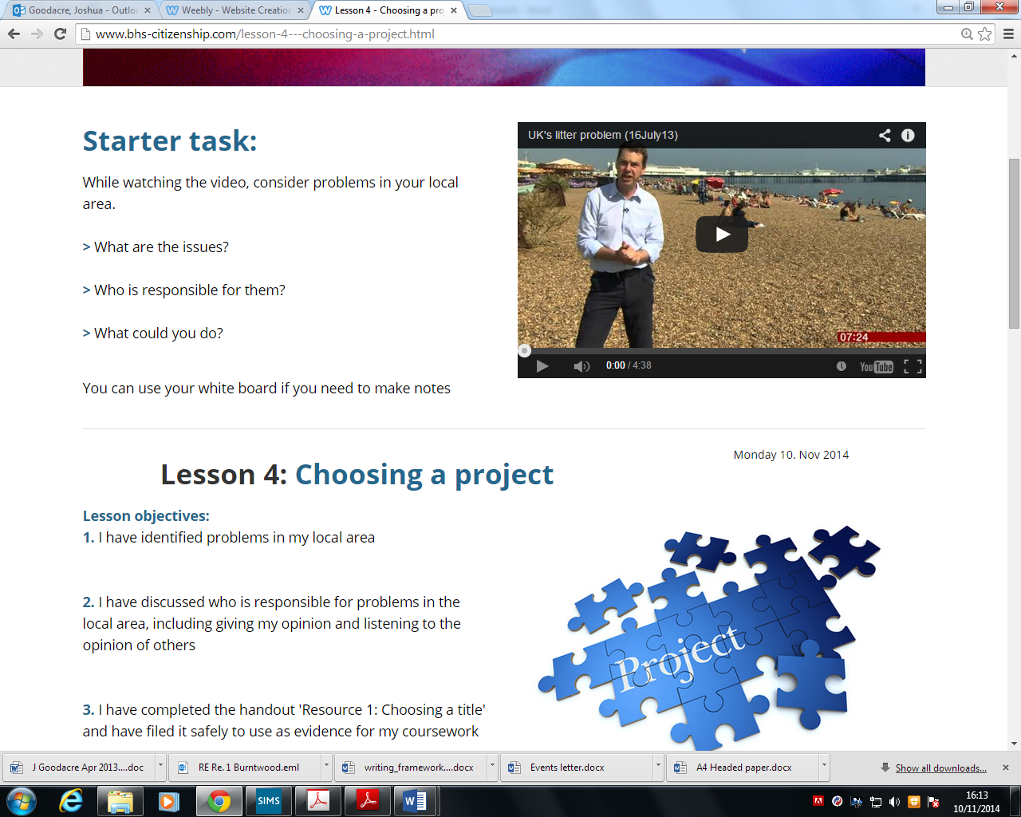

BBC UK’s litter problem – focused on the litter on UK beaches

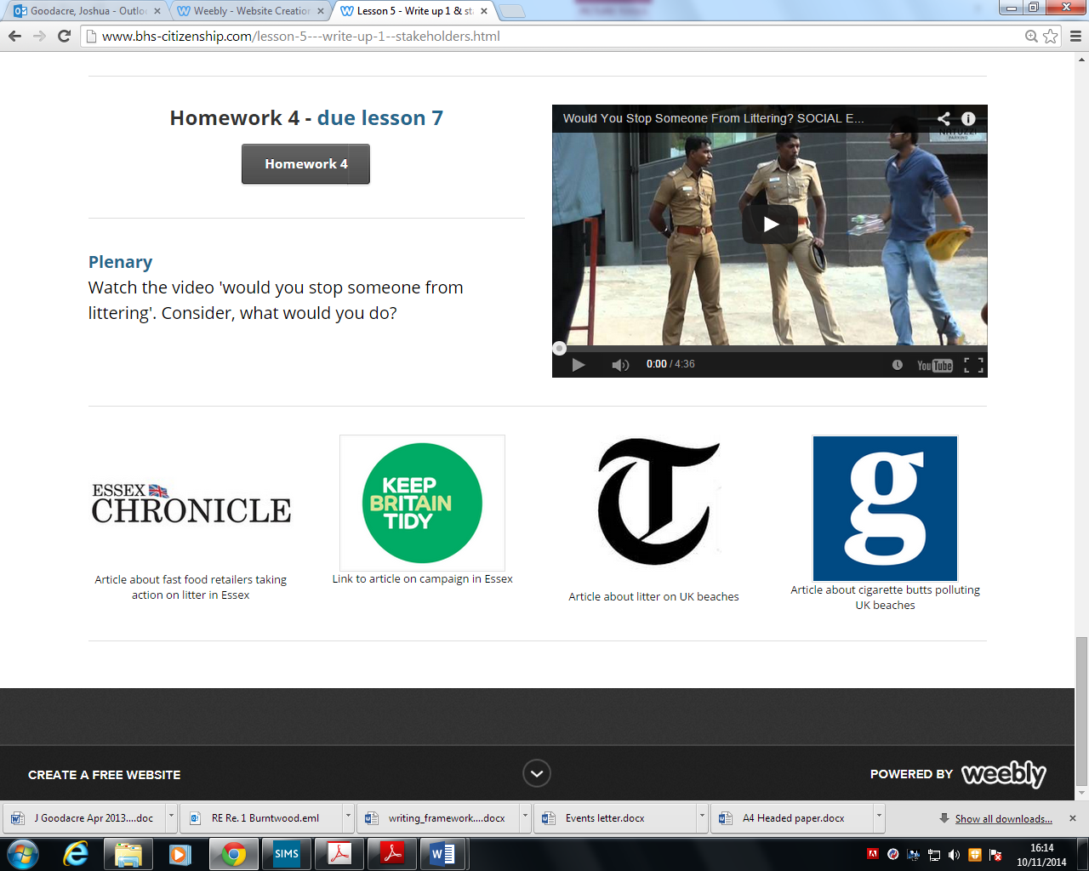

A social experiment to see if people would stop a stranger from littering

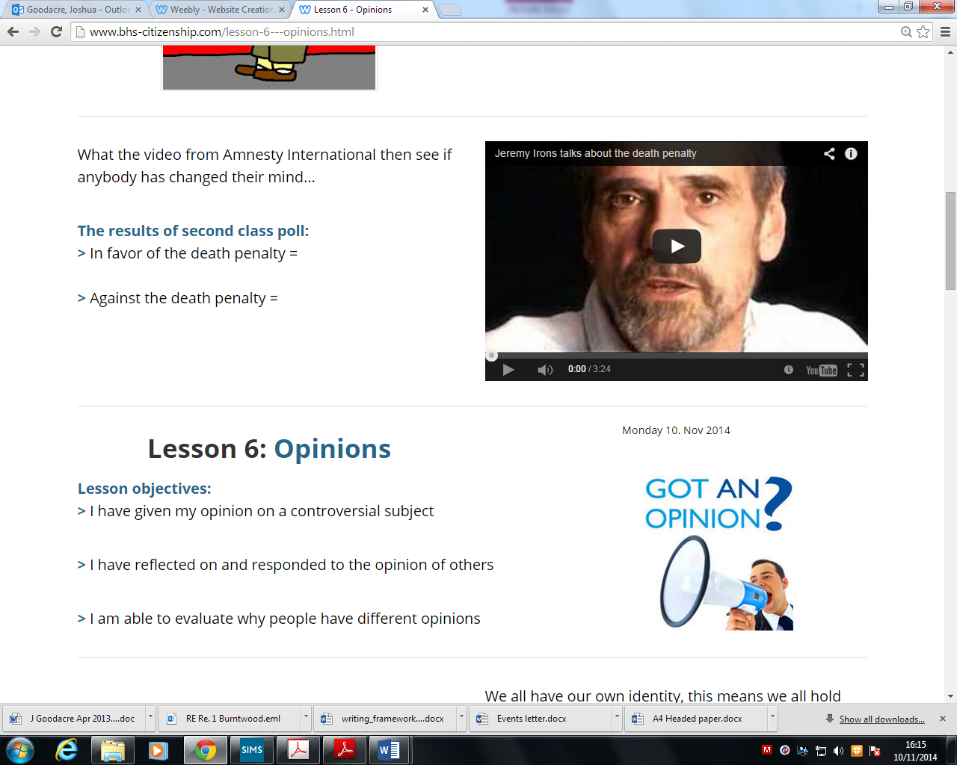

A video where Jeremy Irons talks about why there should be no death penalty

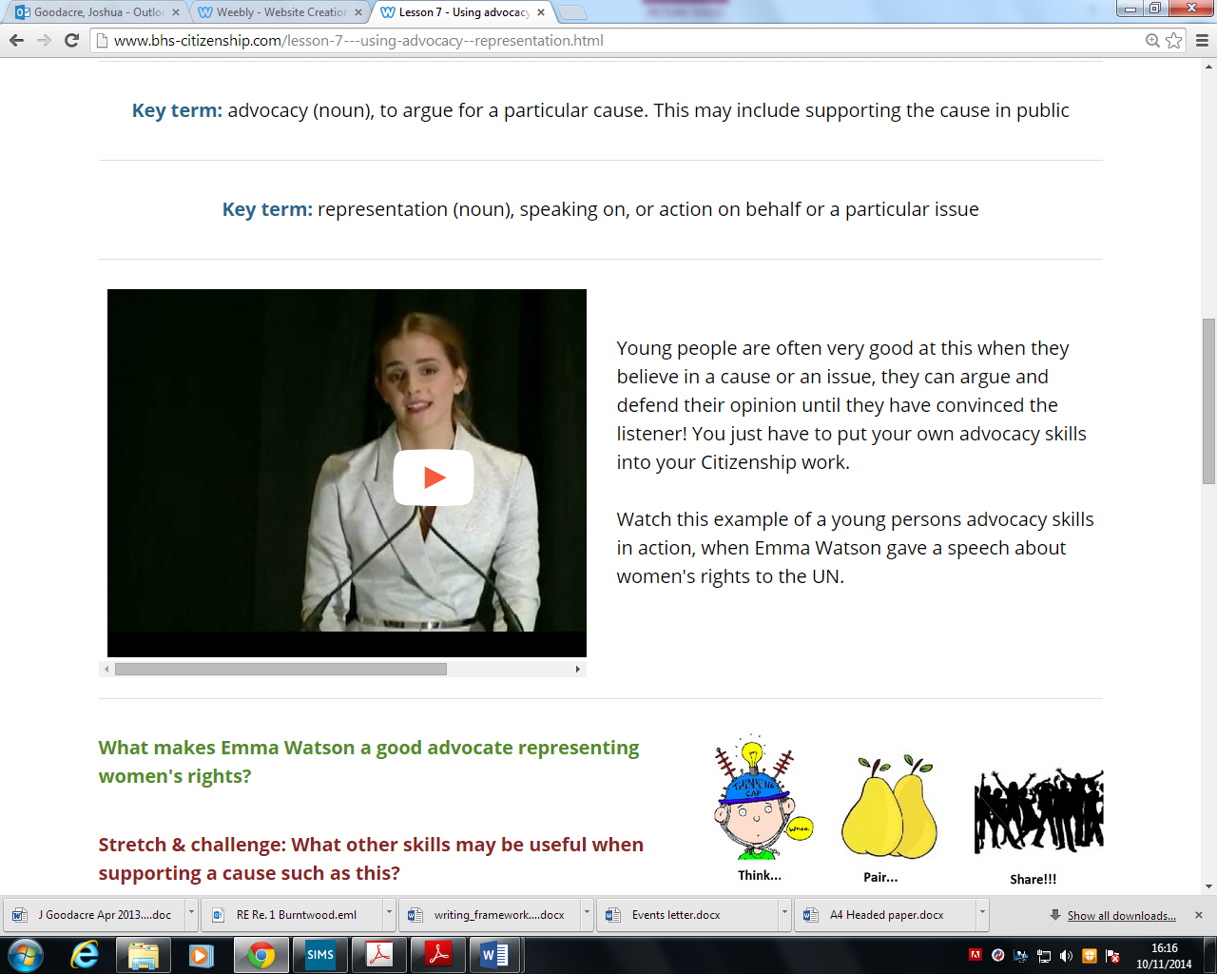

A speech given about women’s rights by Emma Watson

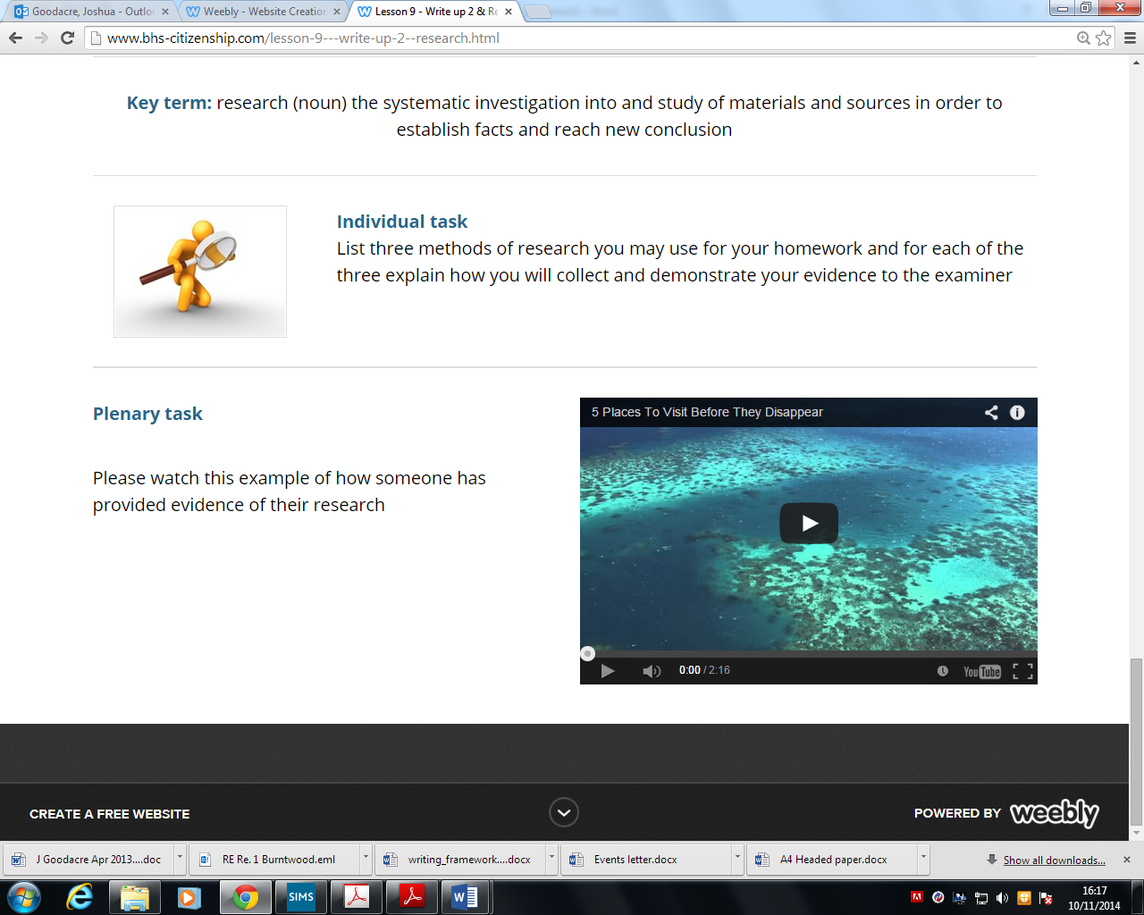

A video about places that will soon be under the sea due to global warming

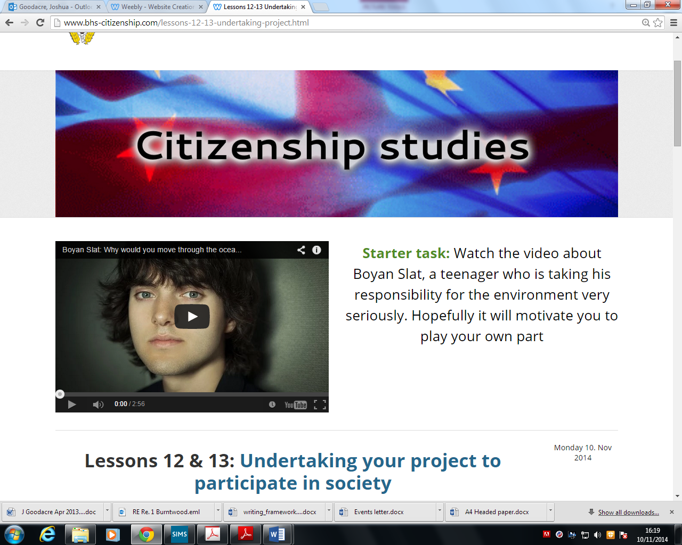

This was about a teenager called Boyan Slat who has been working to clear the seas of rubbish