Name |  | Date

Lesson 6 homework – Exam practice questions
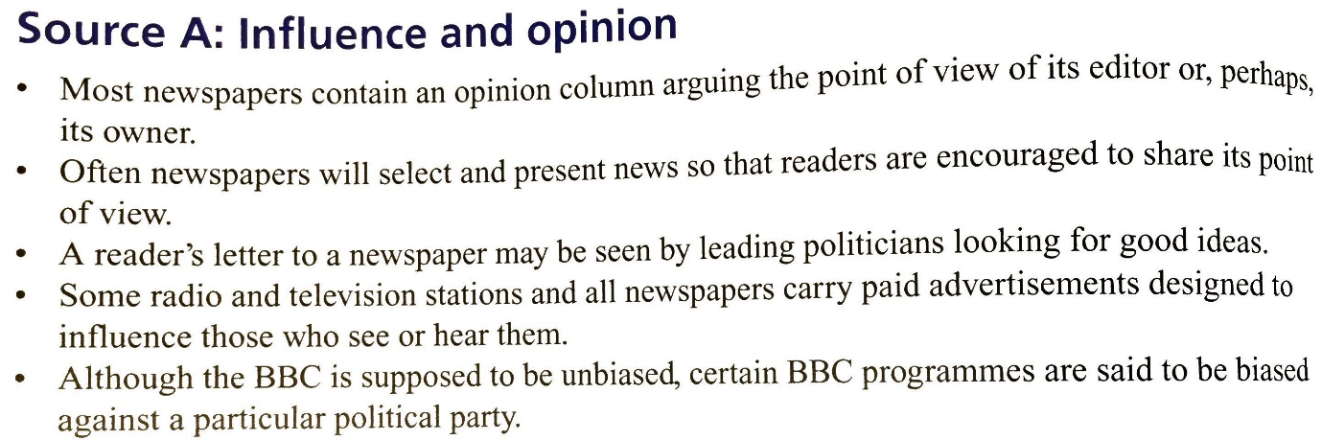
- Why are media owners powerful? (2 marks)
- Use Source A and your own knowledge.
Explain two ways in which public opinion may be influenced by what is printed in the newspapers. (4 marks)
- Use Source A and your own knowledge.
‘Television and radio are much less biased than newspapers.’ Explain two reasons why this claim might be true. (4 marks)
Mark and teacher feedback
/10

