To whom it may concern

This letter confirms that ………………………………………………………………., a year 9 student at Beauchamps High school, was involved with the planning, coordinating and undertaking of two events at the school to raise awareness about littering and improve the local environment.

The first event, a group litter pick took place on ……………………………………
Each member of the group contributed to the event on the day by taking a turn in; identifying problem areas for litter; picking up the litter; and disposing of the bags of rubbish.

The second event, a Citizenship conference that focused on the litter problem at the school, took place on ………………………………………………………......….
Each student was involved with planning the event including who to invite on the panel and what questions each person was to be asked.

Overall every student involved with these events has contributed to improving the environment by clearing unsightly litter as well as making provisions for future actions to be taken to maintain the environment in the long term.

I have been extremely impressed by the actions of each and every student involved in these events.

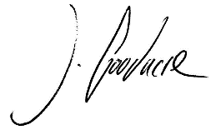
Yours faithfully

Mr J Goodacre
Subject Leader, GCSE Citizenship Studies

